EWU IEEE

Project Weekly Progress Report

  

**Team:** Sensors Team

**Project:** Industrial Sorter

**Date:** 7/26/2020

**What we planned to do last week** (copy/paste/summarize previous week)

Last week we planned to continue research into RGB hex color value conversion and gamma correction for the 16-bit color values returned by the color sensor.

We planned a meeting on Saturday in order to catch everyone up on the development of the color sensor code.

**Supporting Documentation** (website links, GitHub link, pictures)

Basic I2C/Color Sensor Code (initial version that simply obtains 16-bit color values from the sensor): <https://github.com/EWU-IEEE-Spokane/TM4C-I2C>

UART Output: 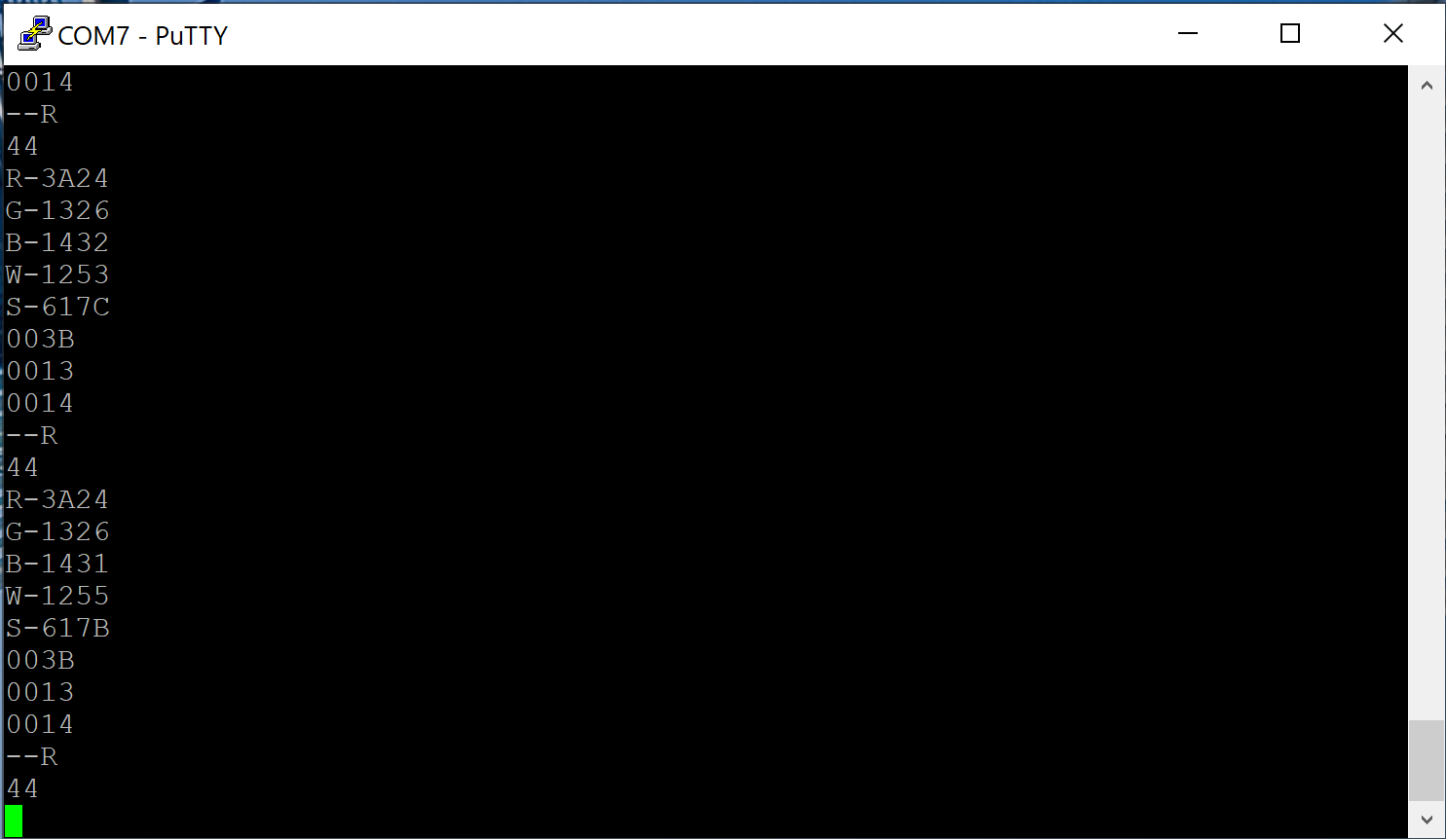

**What we did last week**

time spent total: 7 hours

Research:

* Looked into issues with portability of the I2C code. Amy could not compile the code on a Mac, as the compiler had issues on every for loop. Attempted to eliminate initialization within a for loop, but that did not help.

Software:

* Developed sensor code to remove attempts at gamma correction and dynamic compression.
* Added initial attempts to compare color values in their original 16-bit format.

Hardware:

* Built a testing platform for the color sensor that more closely matches the planned end product (enclosed small black tube with colored objects placed at bottom). Before the development work is finalized the CAD models will be developed for the sensor mount and transport cup to enable real-condition testing.

What it accomplished

* We now are ready to develop actual color binning. Being able to sort objects by color will be the majority of the work needed to command the Motor Controller to move based on sorting results.

Why we were unable to accomplish weekly plan if so

* We had to descope in order to make the coming deadline for sensor/motor integration. It is not necessary to implement hex conversion and gamma correction in order to meet this goal. Our time is better spent getting the necessities done.
* We were unable to get the code running on Amy’s machine, so everyone is not caught up on the development. This should be ok as the plan for continued development is linear so it may be best for one person to finish up these items.
* Had issues with compression/gamma correction. Color correction was not working, and results from sensor were definitely digitally saturated (bit overflow). It is possible that analog saturation is causing the sensor to have an incorrect response to color values, where everything is seen as red. Corrections were started by reducing the gain of the sensor from 60x to 4x. Continued analysis is needed.

**What we plan to do this week**

* Amy will work on parting over the UART code from GitHub in order to gain some insight into why she is having compilation issues. This will also give her a chance to gain familiarity with C for microcontrollers since most of her experience is with assembly language. She’ll also start documenting the setup of Code Composer for the TM4C.
* Cody will develop code that processes the sensor color values into sortation results. The first step will be to resolve the saturation issues so that the sensor returns meaningful values. This may involve tuning of the gain and the integration time of the sensor. It may also be necessary to setup a PWM channel to dim the sensor’s LED.
* Matt will continue camera R&D as time allows, so that there is some refined code ready to be adapted to the camera interface once that is built.
* We need to start communication with the Motion Control Team in order to outline the communication channel between the sensor board and the UMC. We will build a basic interface that drives signals to the motor controller by the end of this week.

How this fits with the overall task/timeline

* We plan to bench test the sensor to motor interface by the end of this week. Getting the sensor to output meaningful color values, then performing a logical sort based on those values will be the majority of what needs to be done on the Sensor Team side of this goal. Adding the motor interface will be more straightforward, though it is dependent on the progress of the Motion Control Team. We will communicate with them in this week’s sorter meeting.
* In order to get meaningful test results from the motor to sensor bench test this week, it may be necessary for the Sensor Team to further descope their design to cut out the incomplete color sorting code. Simply setting up the communication channel and verifying that a list of predetermined sort results can control the motor will give both teams confidence moving forward that they are on the right track. In this case the Sensor Team can add the sorting logic retroactively on top of the tested communication channel.

Why is this important for the project

* Getting this work done will be a major milestone for the project. We will have electronics that will be able to sort objects by color, a communication channel that enables those logical sort results to be passed as control signals to a motor controller, and a motor controller that is able to perform physical sorting.